DIGITAL MARKETING PROJECT

A project work by:

* Amit Kumar Singh (2020305001)
* Divya
* Logesh
* Devadarshini

--------------------------------------------------------------------------------------------------------------------------------------

## Brand Name Creation: Creating a brand name,

## Brand identity Design: Designing a brand logo - using Canva and

## Creating an email account on Gmail to link all your project work

## **Brand Name Creation: Creating a brand name**

#### Brand Name: The Nomads Email: gennextclothing@gmail.com

#### Category: Travel company Logo Theme : Related travel Company

#### Target Audience: Travellers

**Brand identity Design: Designing a brand logo - using Canva.**

Step 1: Opening Canva

opened the Canva software on desktop.

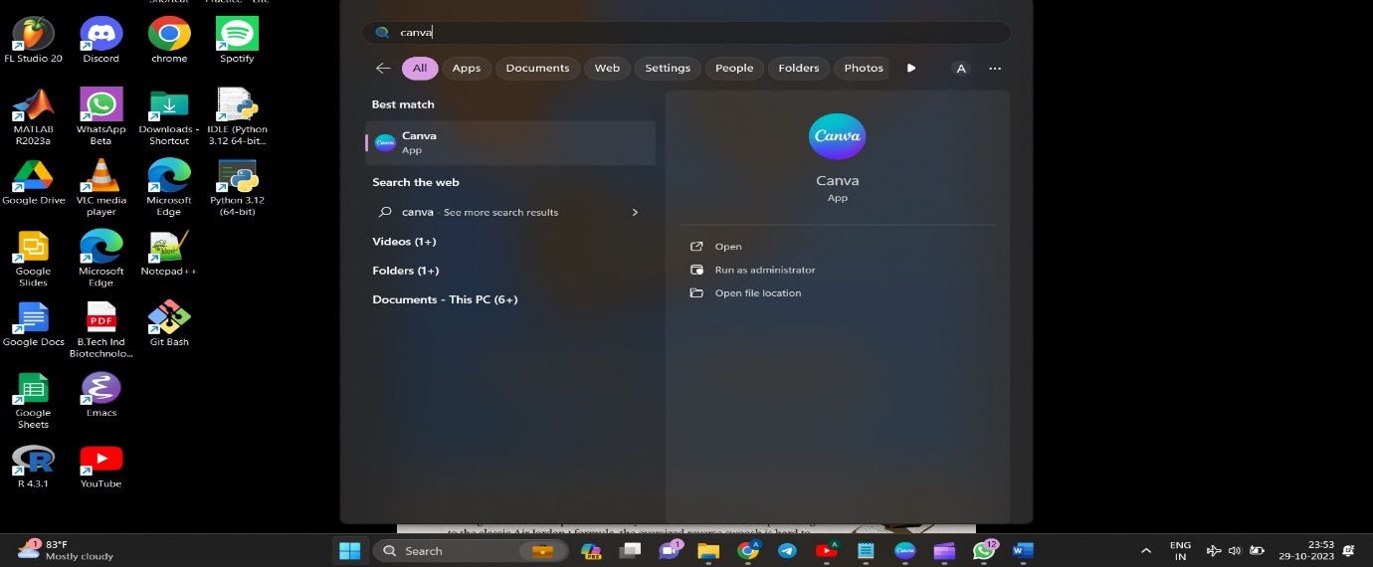

Step 2: Create a design.

selected ‘create a design’ tab chose ‘logo’ and pressed enter. since we had to design a logo, we chose logo but there are multiple task which one can perform.

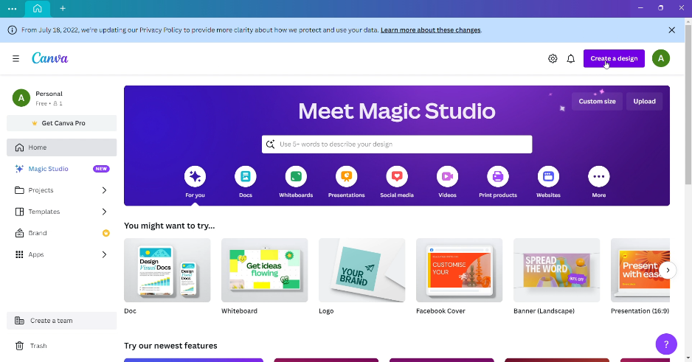



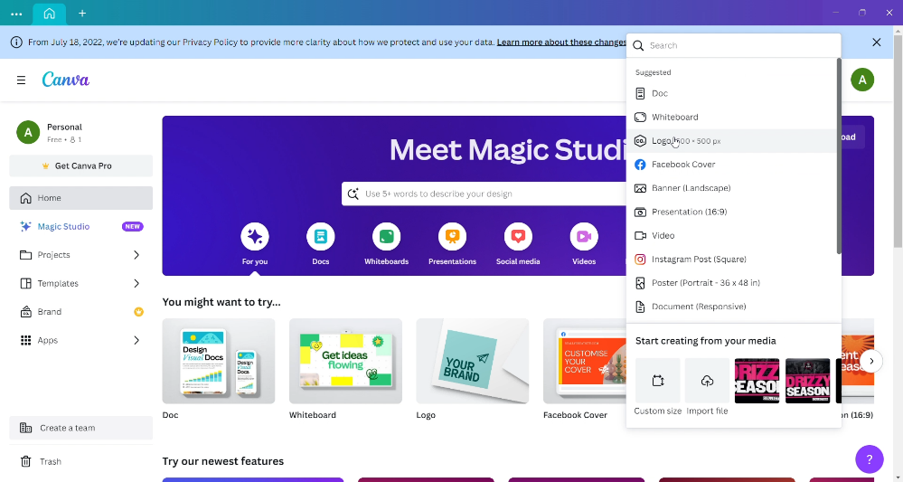

Step 3: ‘Naming the project’.

we named our project as ‘The Nomads’ by clicking at the untitled box at upper right corner of the page.

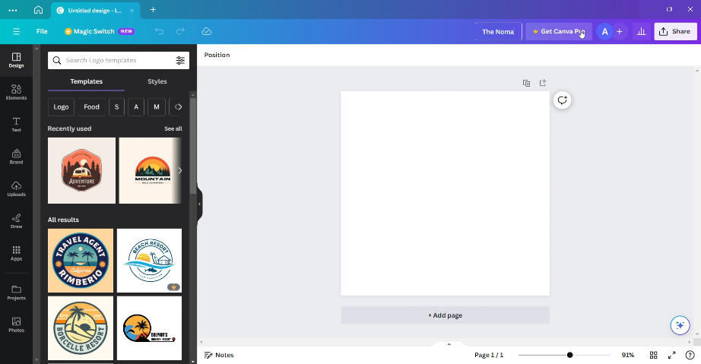



Step 4: Selecting a Template.

We selected a template by clicking at template section. Since we wanted to design a logo for a travel company, we wrote travel in the template search bar and pressed enter which returned us 1000’s of templates related to that. we chose one of the templates which was free to use. We chose our template of interest and dragged it using cursor to the workspace.

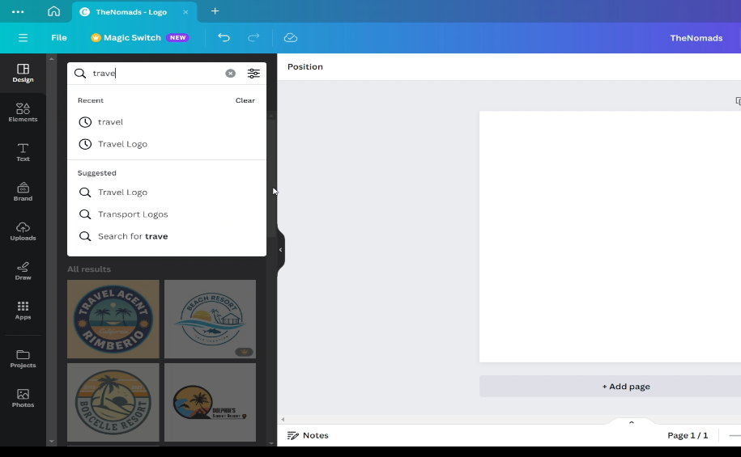



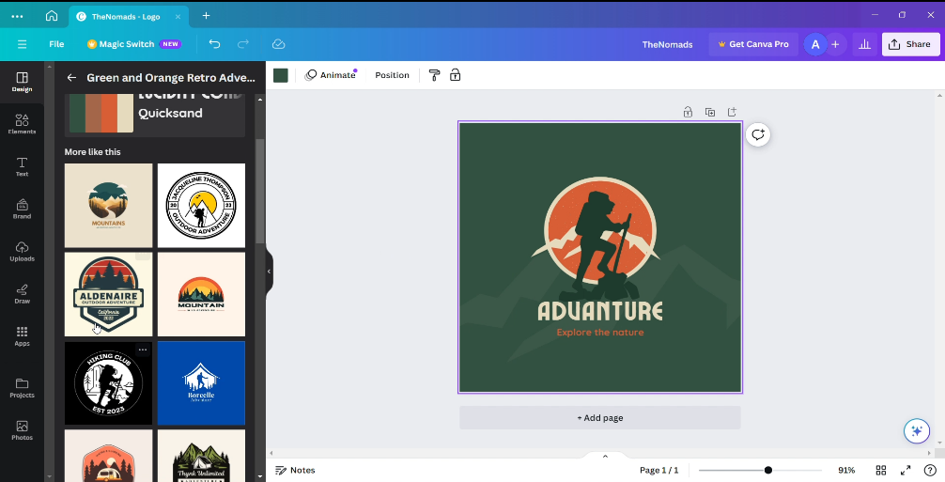



Step 5: Editing The Text

Edited the text which were already there on the template with text of our interest. And changed the font to appropriate one according to our need.



Step 6: change the Colour.

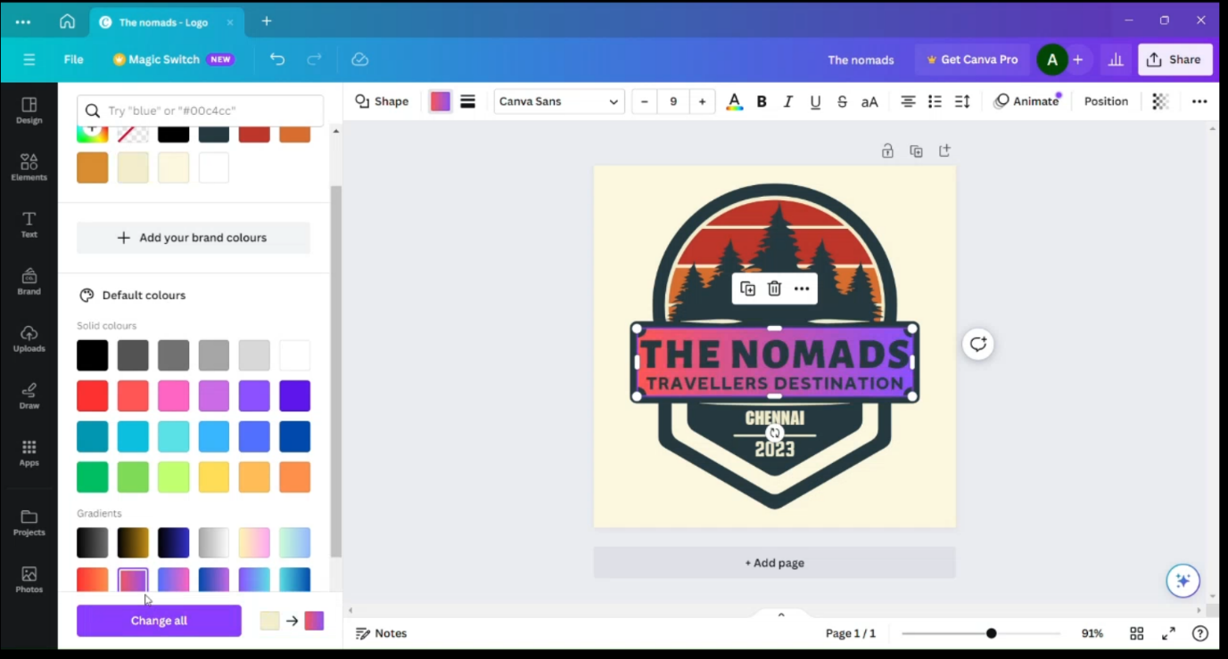We change the color of the boxes by selecting the box for which we want to change the color. After selecting a particular box, a color tab will appear on the top left corner of the page, by using which we can change the box to a different color.



Step 7: Adding Some Element

Clicked on the element section in top left corner. Searched for travel related elements and it gave a lot of travel related result such as graphics, shapes and images.

Added one of the graphics by dragging it to the our logo.

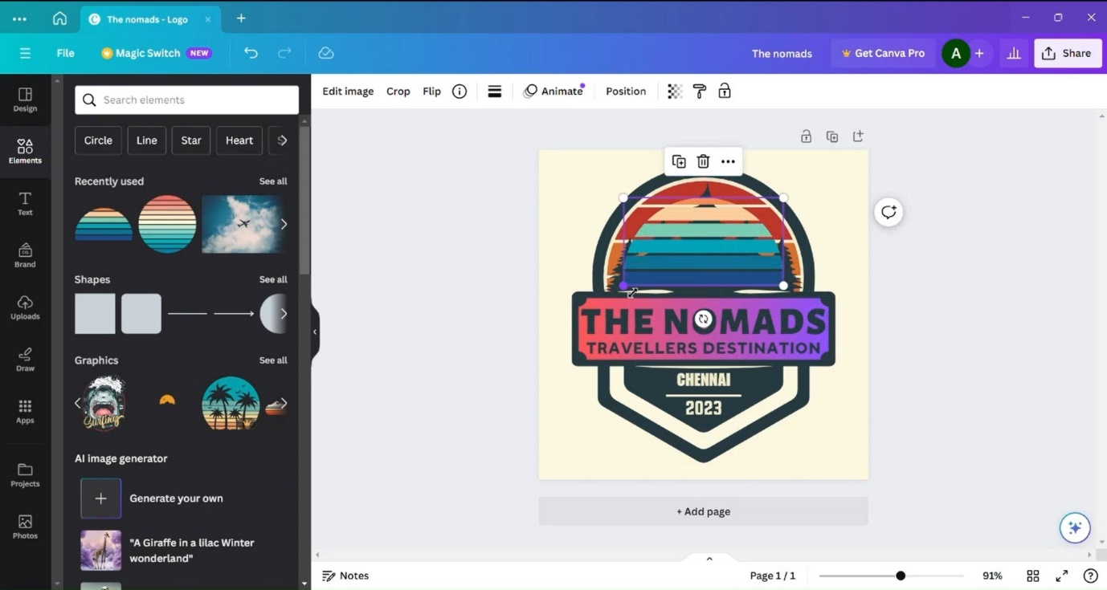



Step 8: Sending the layer backward.

Selected the graphics, clicked to the ‘layer’ and chose to ‘send backward’ to make it appear in the background of the tree.

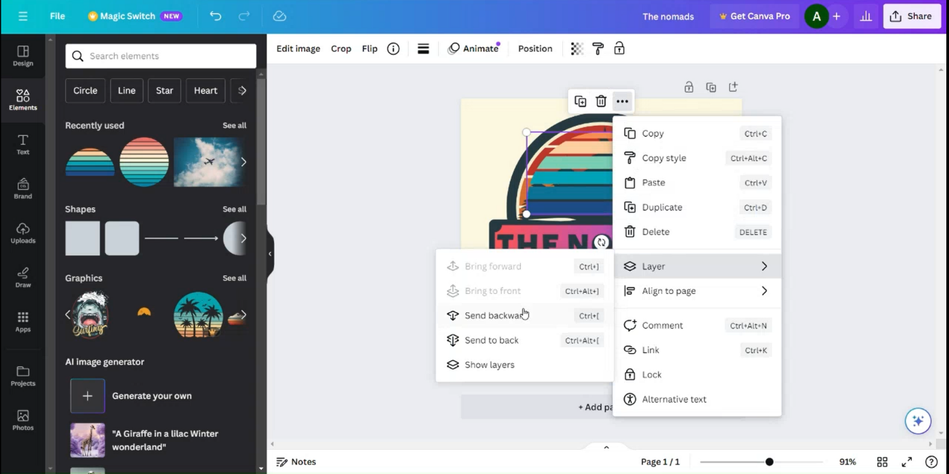

Step 9: Adding an Image

Chose a sky depicted image from the element section, dragged it to the logo and made it as our background of the logo.

Step 10: Replacing The Background.

Selected the image, and right clicked on it then clicked on replace background to make this image as background of our LOGO.

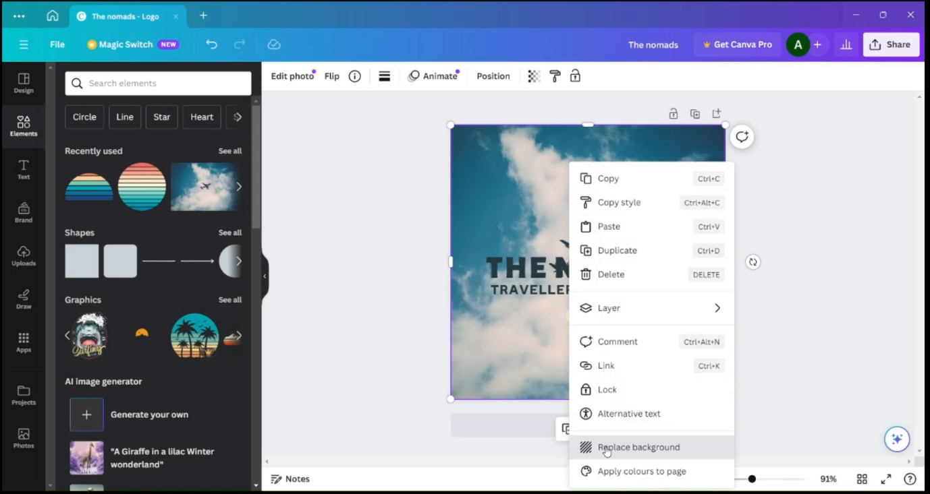

Step 11: changing all the text to same color.

Selected the text Chennai and 2023 and changed the text color to the purple to make it look even with the LOGO.

Step 12: Downloading The LOGO

Finally, our LOGO was ready and downloaded it in PNG file mong the all different file types available.

Step 13: Final Sample

This is our final LOGO which we are ready with.

